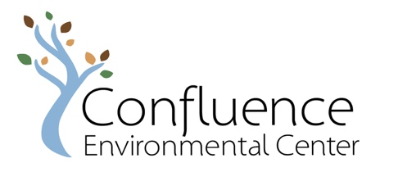

Board Member Position Description

About Confluence Environmental Center
Confluence Environmental Center mission is to advance environmental equity by developing leaders in culturally responsive education, ecological restoration, and cross sector collaboration. Confluence received its 501(c)(3) status in spring of 2013. Confluence Environmental Center’s office is located at 5441 SE Belmont St, Portland, OR 97215.*

Every year we partner with dozens of partners in the region to place an AmeriCorps member for a term of service. At the heart of our programming, we see a cohort of leaders grow together and expand the impact of organizations in our region who are making changes for environmental equity. The outcome of this work is to create greater access to healthy foods, green spaces, clean waterways, outdoor experiences, energy efficient homes, and reliable transportation.

We are actively looking to expand our offerings to deepen our reach and impact in the communities we serve. In 2020, amidst the pandemic, the Staff and Board developed a strategic action plan and revised our mission and vision to reflect what we all felt was needed for the region, pulling on the organization’s history & strengths. In 2021, our “small and mighty” team has continued our programming, successfully navigated complex budgetary challenges due to the pandemic, and now we are excited to grow to meet our vision through external funding opportunities and support from our long-time and new program partners.

About the Board of Directors
We are a working board who takes responsibility for both advancing and overseeing the organization. Our current focus is on creating the tools and systems that will make Confluence an effective and stable organization, including the following:

- Setting Confluence’s direction and priorities for the coming 3-5 years
- Developing and implementing an organizational framework for DEI
- Developing organizational policies, procedures, and infrastructure
- Raising funds and developing partnerships
- Identifying and pursuing new program opportunities

A successful Board member is excited to play a hands-on, working role in organizational development in addition to traditional board responsibilities including policy-setting, fiduciary responsibility, fundraising, and fiscal management.

Expectations of Board Members
Board members must have the capacity, within this volunteer role, to learn the ins- and outs- of our complex operations and bring their own perspective and feedback to ways we can evolve to meet our mission. Board Members are expected to participate in the following ways:

- Attend regular meetings and support work outside of meetings, usually this involves:
  - 2-4 hours for monthly Board meetings (preparation and attendance)
  - 4-6 hours for tasks and communication outside of meetings
- Serve at least one three-year term
- Follow through on tasks and prompt response on emails that require a board vote
- Actively raise funds to ensure the organization has sufficient resources to meet its mission
- Communicate actively, professionally, and in a timely manner
- Be an advocate for Confluence within their sphere of influence
- Act with integrity, passion, wisdom, and dedication to the organization
- Adhere to Confluence’s Bylaws and policies
- While Board members will have other professional affiliations, understand that the participation on the Board is solely for the benefit of Confluence
- Commit to the Confluence mission, and the learning and unlearning involved in supporting environmental justice work
- Donations from Board members are not required to be on the Board.

Board Officers are expected to uphold the responsibilities shared by all Nonprofit officers, including the Duty of Due Care, Duty of Loyalty, and Duty of Obedience as outlined by the Oregon DOJ (please find more about legal rights, roles, and responsibilities, here: http://www.doj.state.or.us/charigroup/pages/tipsbrd.aspx)

How to Apply
For those interested in applying to join the Board of Directors, please start the process by:
- Emailing Board Co-Presidents, Adriana Lovell and Gaylen Beatty, at board@confluencecenter.org with your statement of interest. Include your name, current affiliations, and why you would like to serve in this role.
- After receiving your statement, prospective applicants can join a meeting with Board Members to learn more about the organization and expectations, and to ask your questions.
- After joining a meeting, we ask that you email a completed application to board@confluencecenter.org (see application below). You are welcome to respond to the application questions in the body of an email or an alternative format that works best for you.

If you are interested in securing reimbursement for expenses related to childcare, transportation, software, etc., in order to participate on the Board, please let us know in the comments of your application.

We highly encourage applicants who identify as BIPOC, Latine/o/a/x and LGBTQIA+. We welcome individuals with unique experiences in our region who are willing to challenge system norms to help us build a better organization and future.
Thank you for your interest in Confluence Environmental Center!
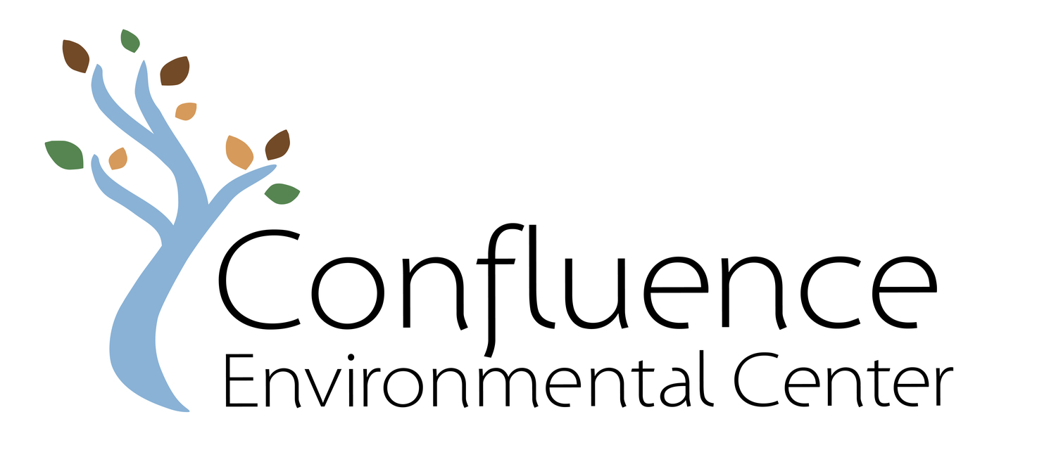

Board Of Directors Application
Name:_________________________________ Date:_________________
Telephone: ______________________________________
Email:___________________________________________

- Why do you want to serve on the Confluence Environmental Center (CEC) Board of Directors and what are you excited to contribute to CEC and the Board?

- How would your personal background and/or professional experiences contribute to CEC’s equity visioning work? Please briefly describe any personal or professional Diversity, Equity, and Inclusion development work you have participated in.

- Confluence Environmental Center mission is to advance environmental equity by developing leaders in culturally responsive education, ecological restoration, and cross sector collaboration. Briefly describe how your professional and/or lived experience prepares you to support CEC’s mission and programming:

- Please describe any prior community leadership experience or past Board experience:

- Do you have any questions to ask the current Confluence Board members or comments about what you would need to most fully participate as a Board Member?

By submitting an application, you agree that you have read through the above commitments and agree to the “Expectations of Board Members” as described in this Board Application Packet.
Send completed application materials or questions
to the CEC Board of Directors - board@confluencecenter.org

